**Business Name change to:**

BTQ Cleaning Services

(Barb’s Top Quality Cleaning Services)

Attention to Detail is the Key!

No other Cleaning will do.

------------------------------------------------------

**Under the logo:**

Experience a clean home that welcomes you back. As premier Halifax house cleaning services, we specialize in customized cleaning solutions with a personal touch.

**Please change to:**

Are you tired of:

* the bigger Cleaning Companies that promise top quality Cleaning?
* not knowing who the cleaners are?
* not receiving the quality cleaning you expect for your hard earned money?

Well! Look no further! I have the solution for you!

I specialize in customized cleaning solutions with a personal touch and comparable prices.

---------------------------------------------------------

Why Choose Us? Please change to:

**Why Choose BTQ Cleaning Services?**

With over 20 years of cleaning experience, I've built lasting relationships with clients who have become friends and family. Starting in 2012, my Halifax house cleaning services business has grown through referrals and word of mouth. Clients often tell me I have a gift with cleaning and that I help remove stress—when you come home to a clean house, you can relax after a hard day's work without worrying about cleaning. Your kids are happy with tidy rooms, and your pets get hugs and kisses while I work.

**Please change to:**

With over 20 years of cleaning experience, I've built lasting relationships with clients who have become friends and family. Starting in 2012, my cleaning services has grown through referrals and word of mouth. Clients often tell me I have a gift with cleaning and that I help remove stress—when you come home to a clean house, you can relax after a hard day's work without worrying about cleaning. Your kids are happy with tidy rooms, and your pets get hugs and kisses while I work.

----------------------------------------

**Our Services**: Please change to:

**My Services**

Every home is unique, and so are our Halifax house cleaning services. I clean houses the way you want, bringing all the products and gear needed to do the job right.

Please change to:

Every home is unique, and so is my cleaning services. I clean houses the way you want, I also bringing all the products and gear needed to do the job right.

-----------------------

### **Regular Home Cleaning**

Thorough Halifax house cleaning services for every room in your home, customized to your preferences. I bring all products and gear, including eco-friendly and pet-friendly supplies.

Please change to:

Attention to detail for every room in your home, customized to your preferences. I bring all the products and gear, including eco-friendly and pet-friendly supplies.

--------------------------------

### **Deep Cleaning – Upon Request**

In-depth Halifax house cleaning services that reach every corner, perfect for seasonal refreshes or special occasions. Using advanced vacuum backpack technology with 3 filters to ensure dust-free results.

**Please change to:**

During the seasons changing or special events, I provide detail cleaning for:

* interior windows/frames,
* doors & frames,
* baseboards,
* entry closets floors,
* oven interior & exterior,
* fridge interior & exterior,
* microwave interior & exterior,
* Laundry done but not put away,
* change bedding,
* dishes and put away,
* kitchen cupboards & drawers.

---------------------

### **Specialized Cleaning Leave as is I like this one!**

Serving all clients—from families with kids and pets to elders with disabilities. Your pets get extra love while I work, and your home gets the attention it deserves.

------------------------

### **Move-In/Move-Out Cleaning**

Comprehensive Halifax house cleaning services for your transition. Whether you're moving in or moving out, we ensure your space is spotless and ready for your new beginning.

**Please change to:**

Comprehensive cleaning services for your transition. Whether you’re moving in or moving out, I ensure your space is spotless and ready for your new beginning.

----------------------------

**Quality Halifax House Cleaning Services (Please remove this line)**

## Discover the BTQ Difference

## please change to:

## Discover the BTQ Cleaning Services Difference

I clean houses the way you want—every home and owner is different. As your trusted Halifax house cleaning services provider, I bring all the products and gear needed to do the job right, including environmentally and pet-friendly products. My vacuum backpack cleaner with 3 filters ensures dust doesn't enter your house. I clean your house and take away your dirt.

**Please change to:**

I clean your home the way you want—every home and owner is different. I bring all the products and gear needed to do the job right, including environmentally and pet-friendly products. My vacuum backpack cleaner with 3 filters ensures dust doesn’t enter your home. I clean your home and take away your dirt!

--------------------------------------

**Customized for Every Home+**

Every home is unique, and so are our cleaning solutions. I tailor my approach to match your specific preferences and needs.

**Please change to:**

Every home is unique, every client/family is different, so is my cleaning solutions. I tailor my approach to match your specific preferences and needs.

------------------------------------

20+ Years of Experience+

Started cleaning houses in 2012, with over 20 years of Halifax house cleaning services experience total. Most clients come from referrals and word of mouth.

**Please change to:**

Started cleaning houses in 2012, with over 20 years of house cleaning services experience total. Most clients come from referrals and word of mouth.

------------------------------------------

**All Your Needs Covered+**

Please leave as is I like this one

Serving clients of all ages—from families with kids and pets to elders with disabilities. I show pets respect and gentleness, earning me the nickname 'Pet Whisper' from clients.

----------------------------------------------

**Advanced Equipment+ Leave as is**

Using a professional vacuum backpack cleaner with 3 filters that ensures dust doesn't enter your home during cleaning.

-------------------------------------

## Frequently Asked Questions

Here are some common questions we receive from our clients.

**Please change to:**

Here are some common questions I receive from our clients.

--------------------------

## What areas do you serve?

Our Halifax house cleaning services cover various neighborhoods throughout Halifax and surrounding areas. Please contact us at 902-220-1089 or btqcleaningservices@gmail.com for specific locations.

**Please change to:**

BTQ Cleaning Services cover various neighborhoods throughout Halifax and surrounding areas. Please contact us at 902-220-1089 or btqcleaningservices@gmail.com for specific locations.

-----------------------------

## Do you bring your own supplies? Please leave this as is.

Yes! I bring all necessary cleaning supplies and equipment, including eco-friendly and pet-friendly products. My professional vacuum backpack cleaner with 3 filters ensures thorough cleaning without dust entering your home.

-------------------------------------

## How do I book a service?

Booking is simple! Call us at 902-220-1089, email btqcleaningservices@gmail.com, or message us on Facebook. We'll work around your schedule to find a time that's convenient for you.

**Please change to:**

Booking is simple! Call 902-220-1089, email btqcleaningservices@gmail.com, or message me on Facebook. We'll work together to find a schedule that is convenient for both of us.

------------------------------------

## Are you bonded and insured?

Yes, I am bonded, insured, dependable, and reliable. I take pride in my work and build solid relationships with clients based on trust and satisfaction.

**Please change to:**

Yes, I am bonded, dependable, and reliable. I take pride in my work and build solid relationships with clients based on trust and satisfaction. Upon request, I can provide a criminal background check record.

-----------------------------------------------

## Do you clean for families with pets? Please leave as is I like this one.

Absolutely! I'm known as the 'Pet Whisper' by my clients. I show pets respect and gentleness while cleaning. Your pets get hugs and kisses, and I ensure all products used are pet-friendly and safe.

---------------------------------------------

**Photos messages:**

Halifax House Cleaning Services Gallery

**Please change to:**

BTQ Cleaning Services Gallery

## Transformations We Create

## Please change to:

## Transformations I Create

Browse through our gallery to see the beautiful clean spaces our Halifax house cleaning services have achieved for our clients.

**Please change to:**

Browse through my gallery to see the beautiful clean spaces my cleaning services have achieved for my clients.

---------------------------------

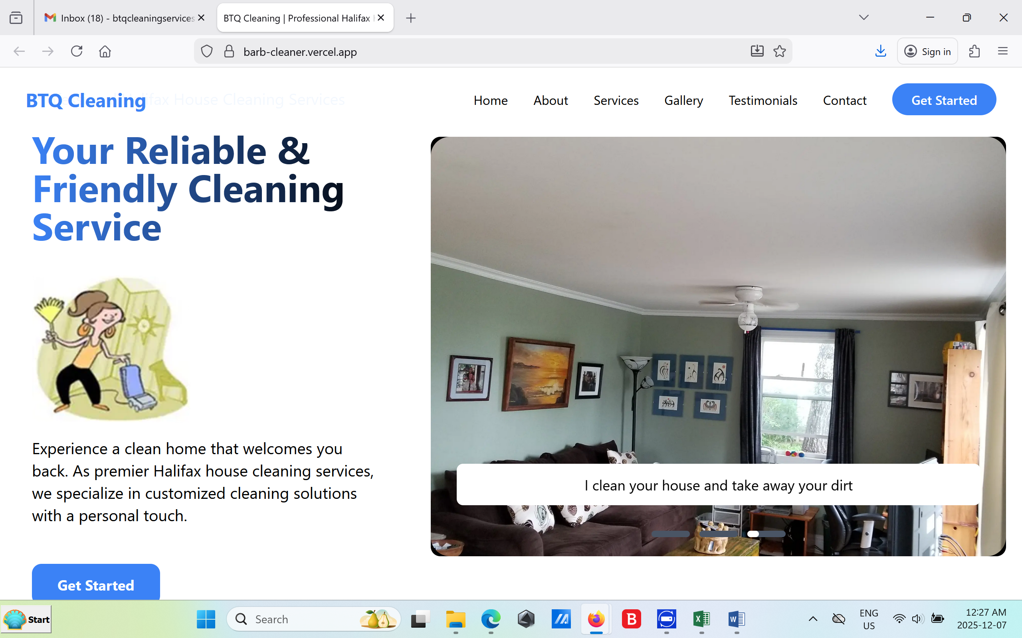

Leave this photo as is.

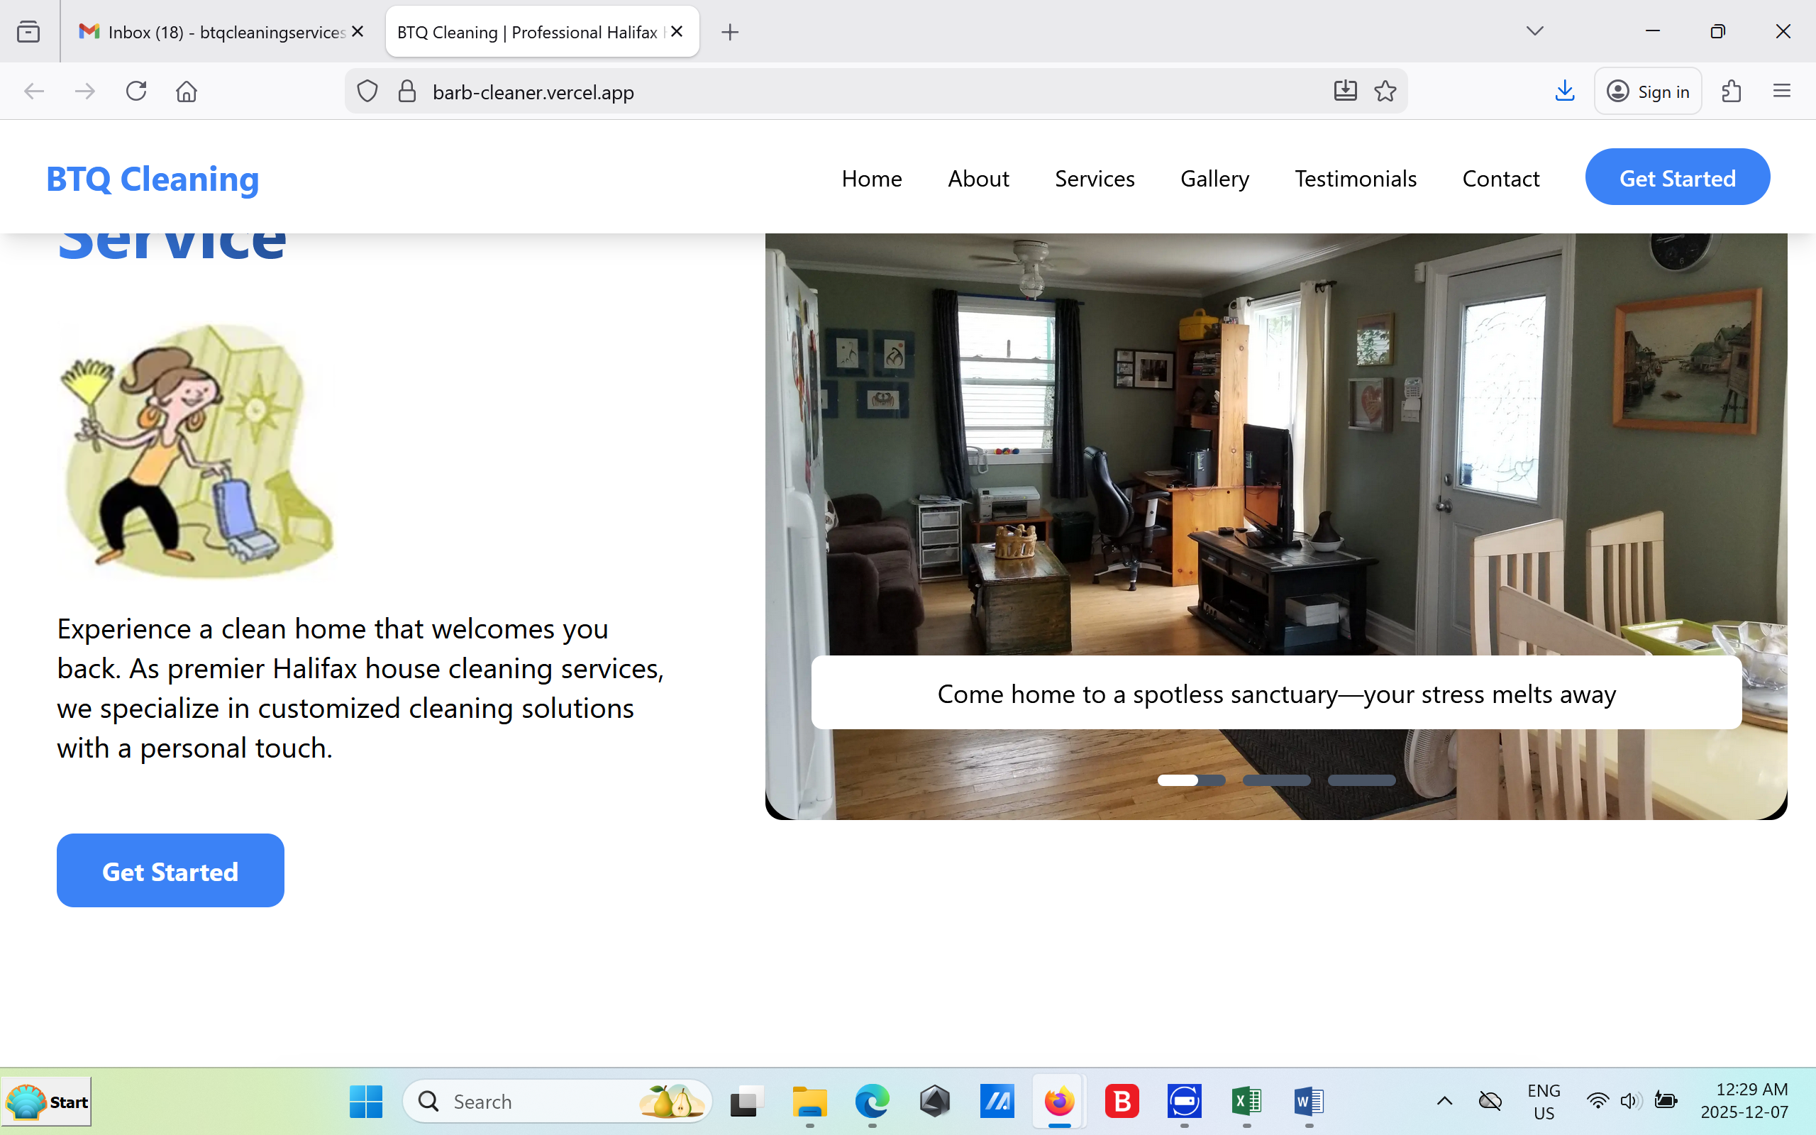

Leave this photo as is.

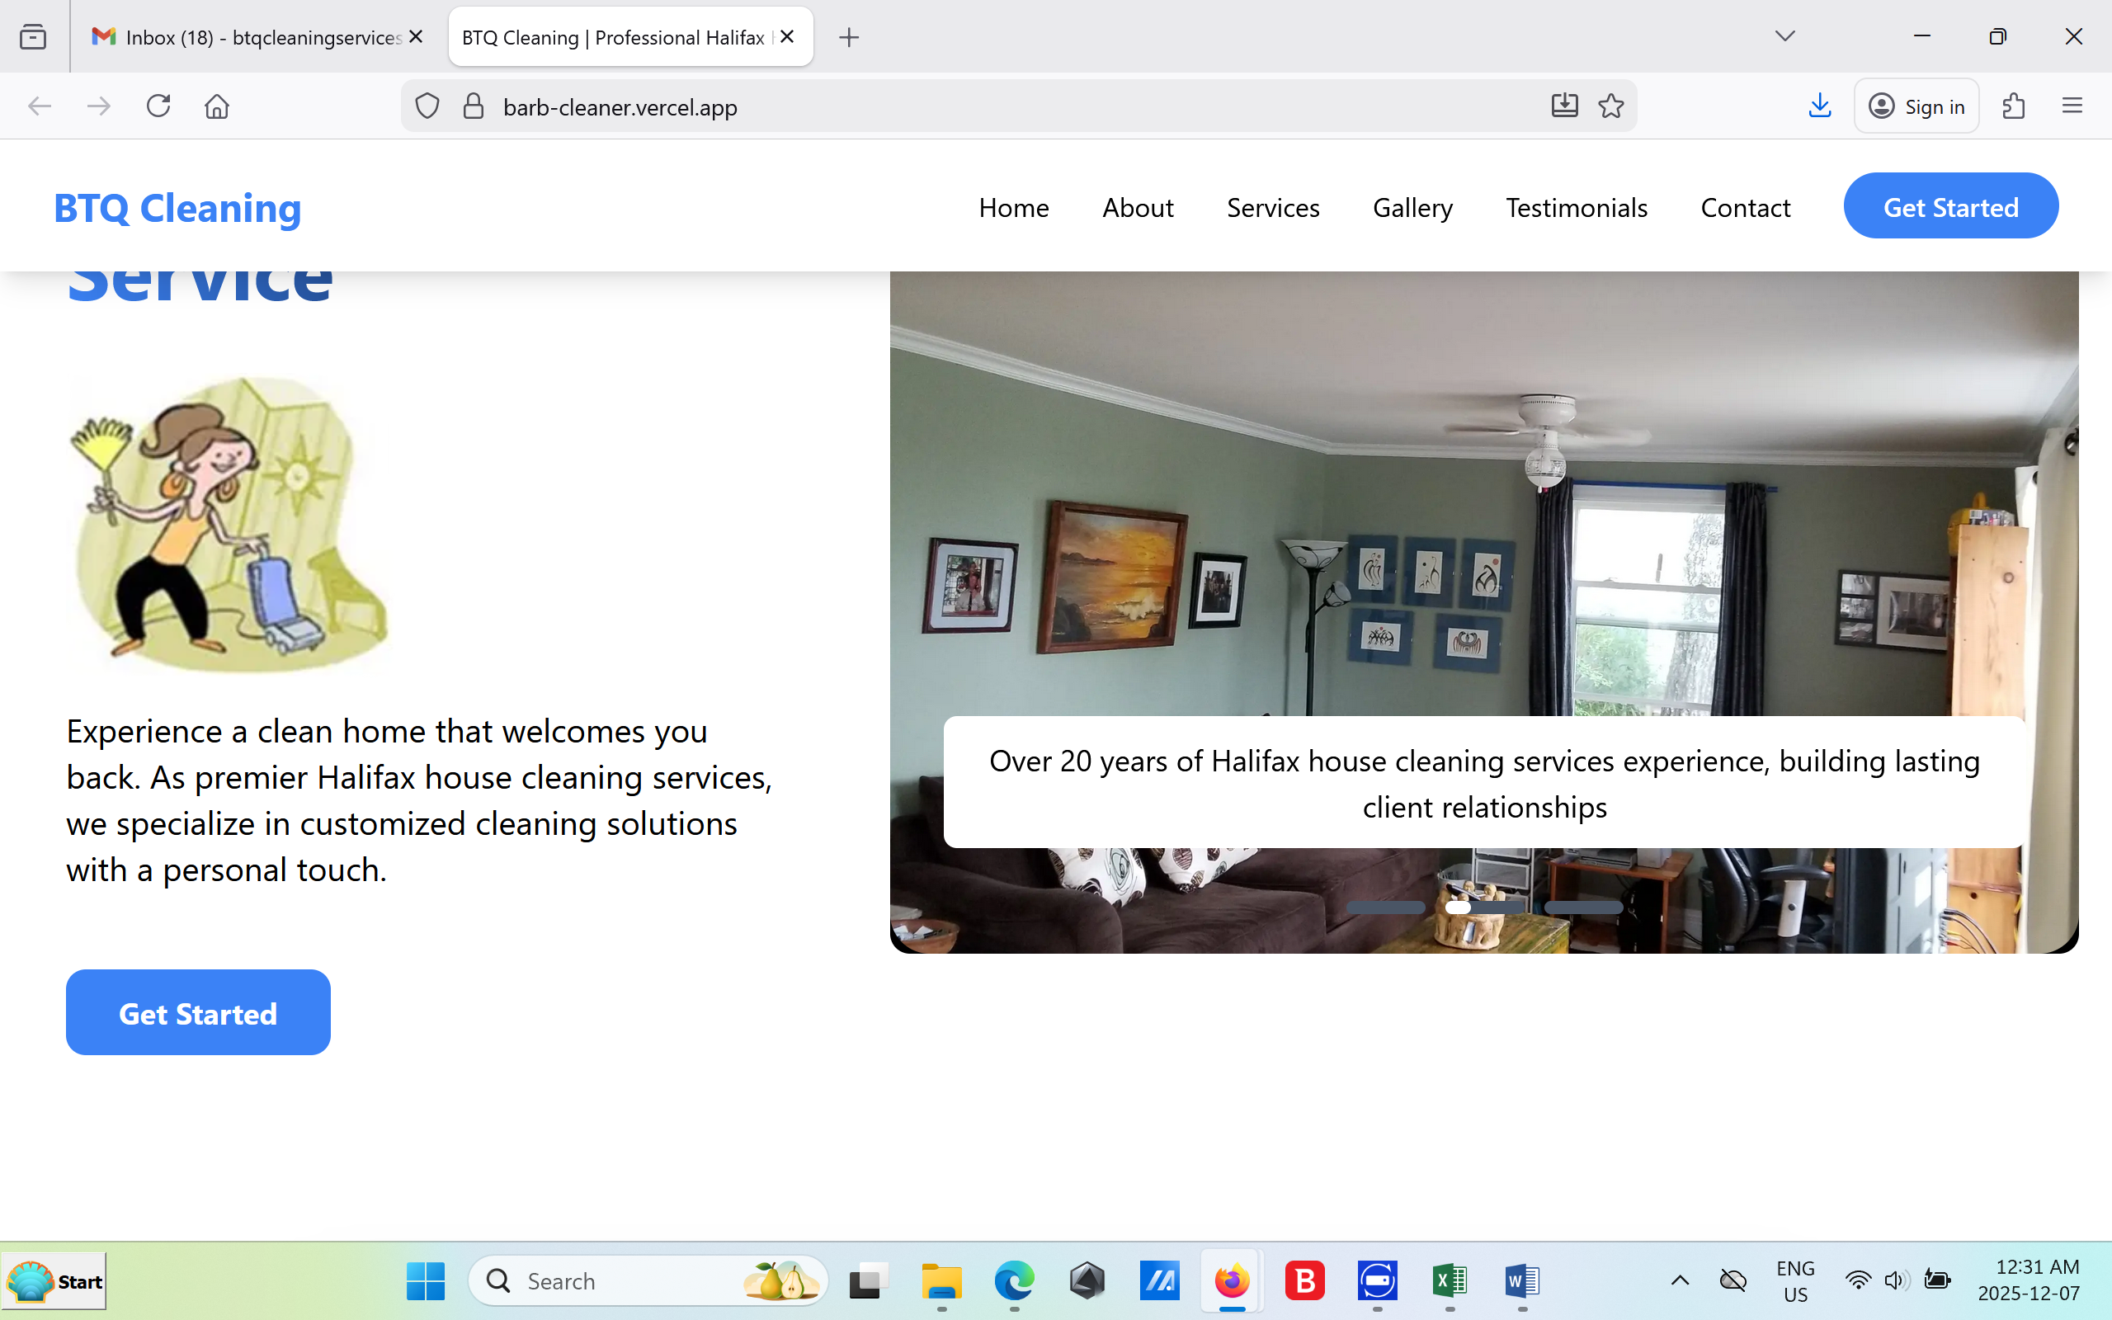.

Please change message on this photo to:

Over 20+ years of house cleaning experience, building lasting client relationships.

------------------------------------

Please add 2 more photos to the gallery please.

Me holding the bird and the dog sitting at the top of the stairs.

-------------------------

I hope I covered all the areas. This site is bigger than I thought. But I like it. Its simple and its very nice to navigate!

Thank you for your hard work, I truly appreciate this.

Oh will your website show at the bottom to help advertise your work? If not it should be there.

Thank you Thomas!

Barb ☺

Ps. please correct any typos that I may have missed. ☺